Improvement at the College of Micronesia – FSM:
Review of Options

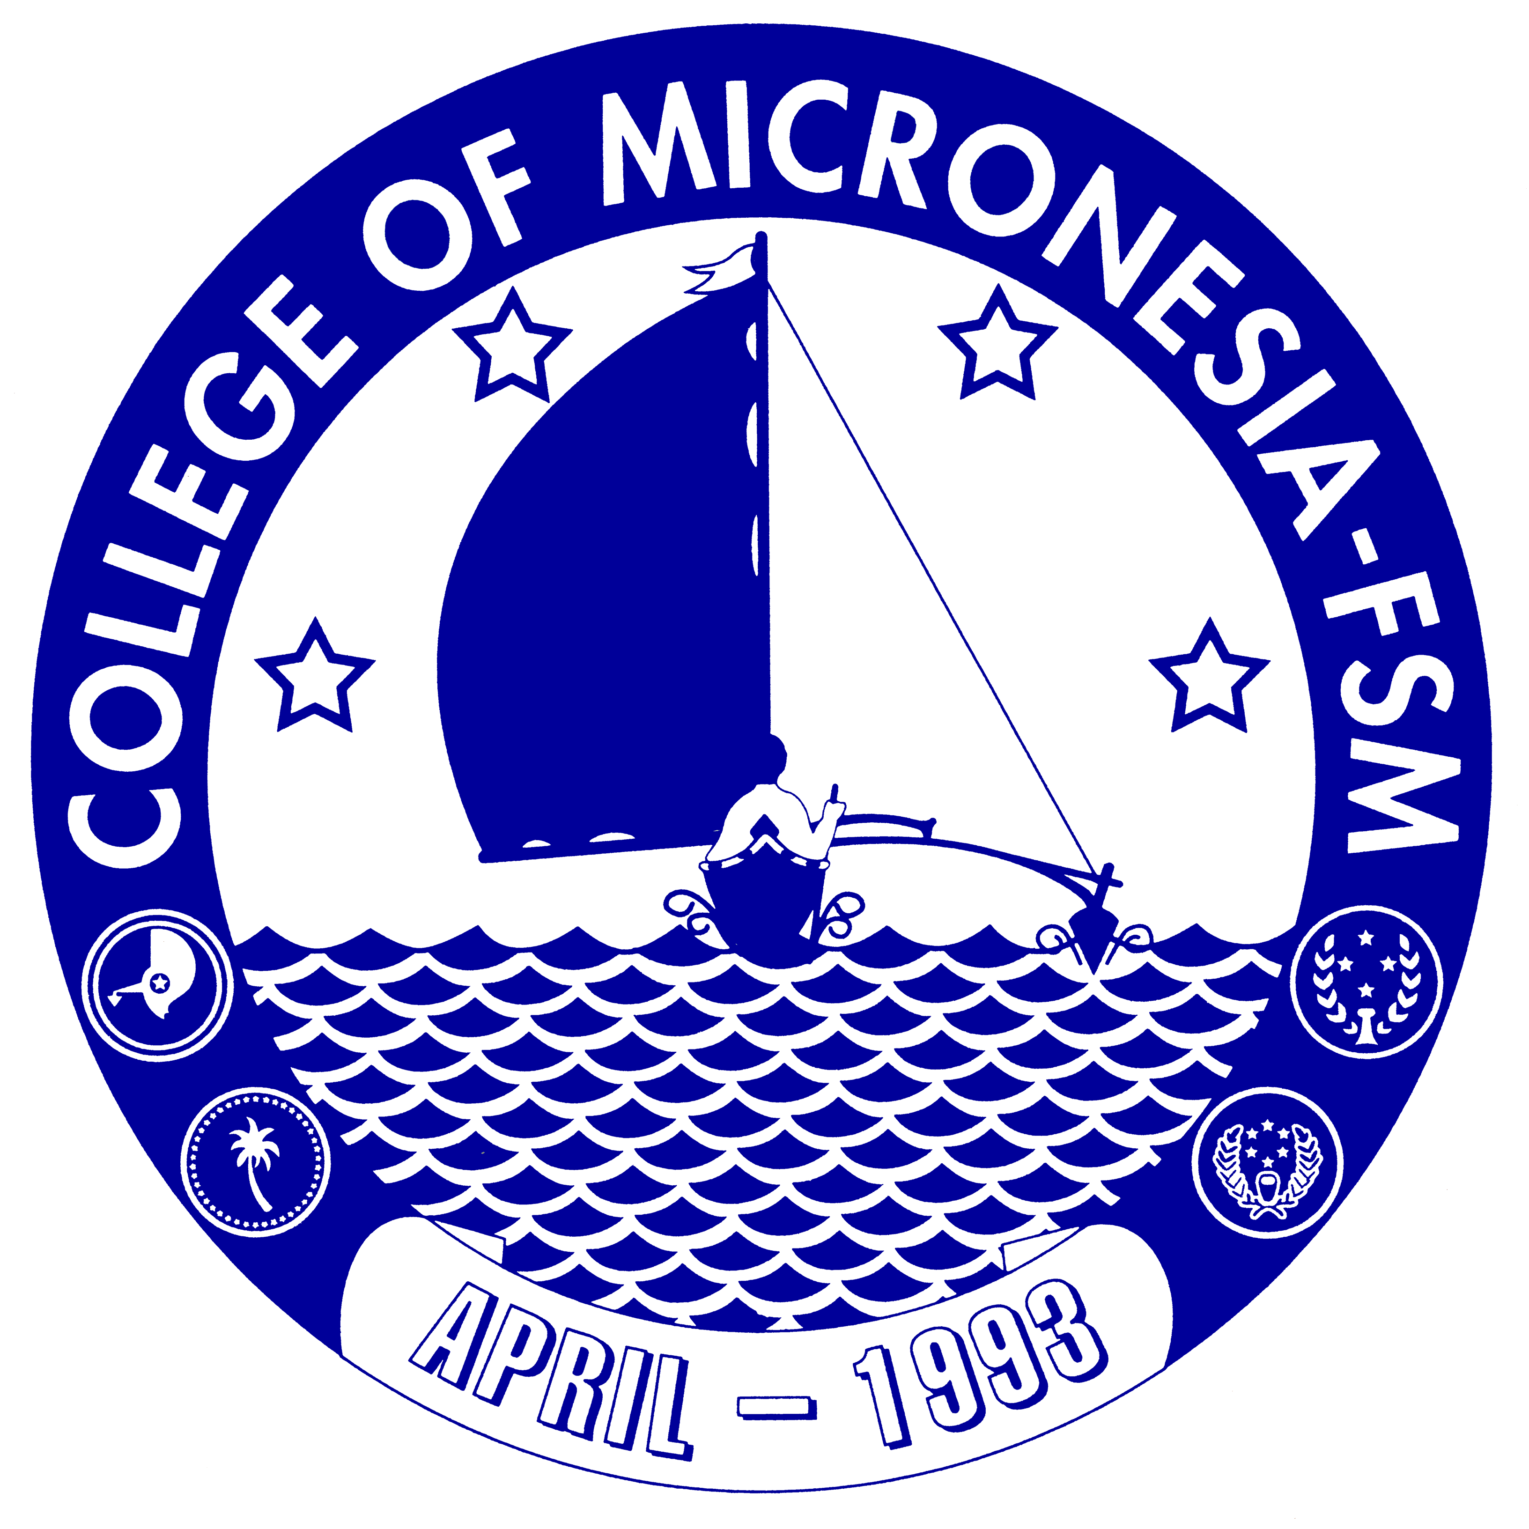

A look at possible options for the direction of the College of Micronesia – FSM by invitation of His Excellency, Manny Mori, President of the Federated States of Micronesia

Submitted by:
Spensin James

November 30, 2007

